**Finding Location for New Fitness Studio in**

**Hamburg, Germany**

Kadir Karatas

26.07.2020

**Introduction**

My project is about opening new fitness studio in Hamburg, Germany. Since it is very popular to go fitness studios and build muscles. It is a trending business to open fitness studios. In Hamburg there are in total 104 areas and 7 regions. According to foursquare dataset and frequency of the studios, we will decide to where open the new studio.

## Data Description

As dataset I am going to use Wikipedia and Foursquare. On the following link, there is list of areas and their coordinates: <https://de.wikipedia.org/wiki/Liste_der_Bezirke_und_Stadtteile_Hamburgs> In order to obtain latitude and longitude, the geolocator funtion will be utilized. And for the fitness studio location I am going to use Foursquare data.

## Methodolody:

## Raw data:

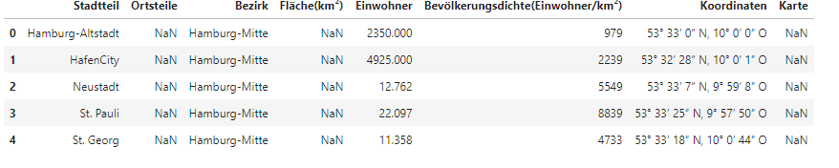

## Data after data wragling:

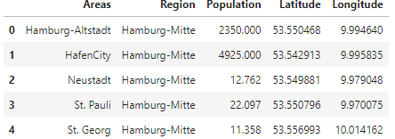

## Areas on the Hamburg’s Map:

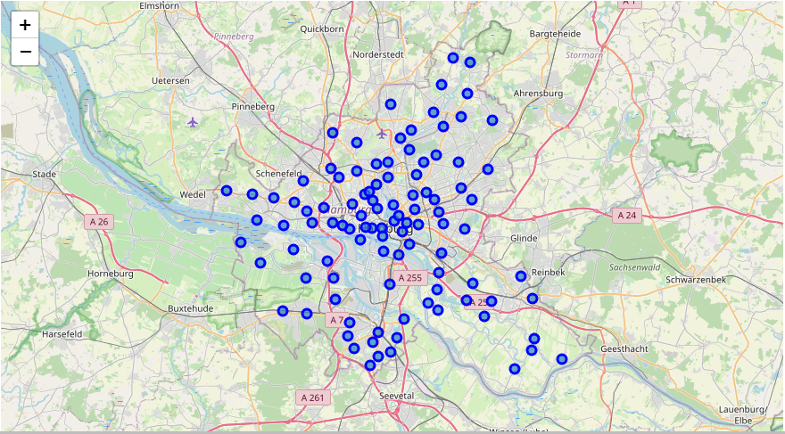

## Obtaining Veneu Location of Hamburg:

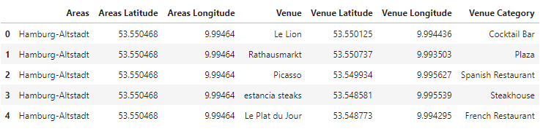

## Filtering on Fitness Studios:

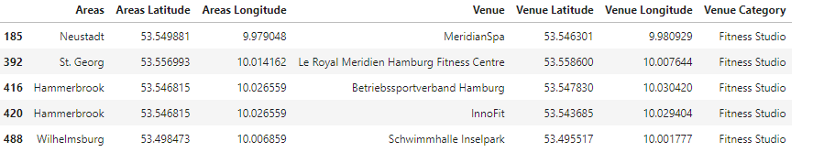

## After Visualisation of the Clustered Fitness Studios in Hamburg

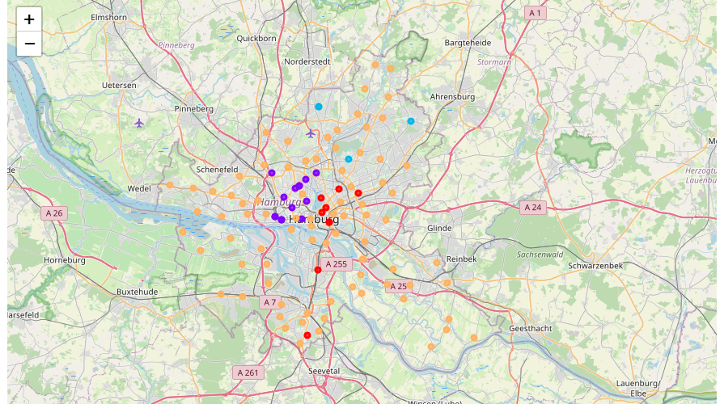

## Results

In the light of analyses we can come up with the idea of openning fitness studios on the orange colored areas. Because on the map these are the areas which are not able to assigned any cluster. On the other hand, the dark blue areas are, as expected, full with fitness studios, while being city center. After dark blue, red and light blue areas also seem having relative high numbers of fitness studio.

## Discussion

When we evaluate the results, we have to consider the reliability of the veneu data. As a person living Hamburg, the number of fitness studio in Hamburg should be around 27. However, the results have reasonability while the density of fitness studios are increasing in the city center.